**iHome Rentals**

2013

**User Manual for APP**

**Documentation**

**Arivanandhan Pandian**

Table of Contents

Start Screen 3

Search Screen 4

View list of Houses Screen 5

Result Screen 6

Detail Screen 6

Send Email Screen 8

Make Call Screen 9

Save Picture Screen 10

## Start Screen

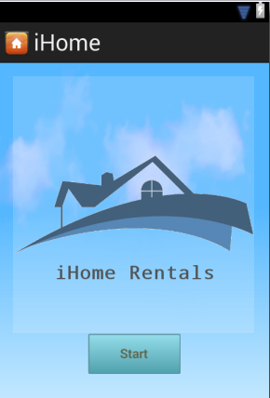

User will able to start the application by using the start button, which will go to next screen.

## Search Screen

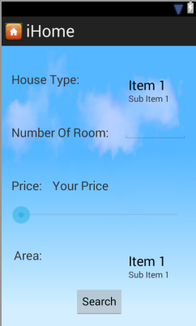

* User will able to search the specific home rentals.
* **House Type:** user will have three choice in the dropdown list which contains Condo, Apartment, and Basement.
* **Number of Room:** user will able to type numbers of rooms needed and it will be validated. For example, user can type 1, or 2 or 3 etc.
* **Price:** user will able to drag the bar to view selected price that desired for the house.
* **Area:** user will able to select the dropdown list which user will select the place to rent the house. The dropdown list will be Toronto, Markham, Scarborough and Mississauga.
  + **Note:** There might be some more places to add in the list according to user request.

## View list of Houses Screen

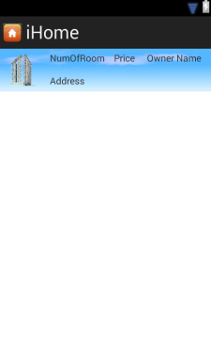

* User will able to retrieve results according to user input search. It will show list of houses.

## Result Screen

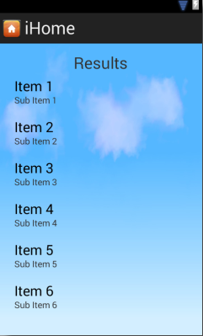

* User will able to retrieve results according to user select the house.

## Detail Screen

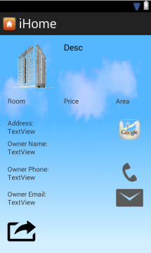

* User will able to get detailed information about the house and it has list of icons which user can check Google map, call owner, send email, share Facebook, share Twitter, share via email, and share via SMS message.

## Send Email Screen

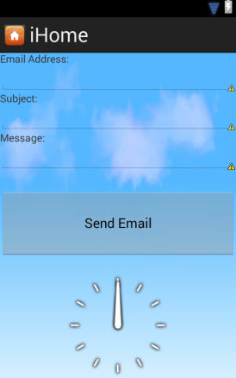

* User will able to send email to owner, and it will display current time in the local.

## Make Call Screen



* User will able to will able make call to the owner by clicking the button.

## Save Picture Screen

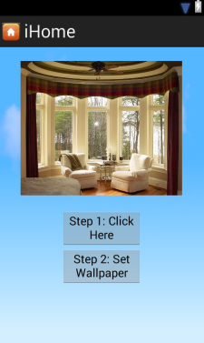

* User will able to save the picture to the SD Slot and can set the picture as a wallpaper in the home screen of the mobile.